Software Requirements Specification
for
University Club Website
Version 1.0 approved
Prepared by
Hilal TURKYILMAZ, Beyza ŞAHIN and Esmanur AYTAŞ
Istanbul Medipol University
17.10.2024
Contents

1. Introduction 1
1.1 Purpose 1
1.2 Document Conventions 1
1.3 Intended Audience and Reading Suggestions 2
1.3.1 Backend Developer 2
1.3.2 Frontend Developer 2
1.3.3 Database Administrator (DBA) 2
1.3.4 UI Designer 3
1.3.5 Project Manager 3
1.3.6 Test Specialist 3
1.3.7 Users 4
1.4 Product Scope 4
1.5 References 4
1.5.1 Original SRS Template 4
2. Overall Description 5
2.1 Product Perspective 5
2.2 Product Functions 5
2.2.1 User Registration and Authentication: 5
2.2.2 Event Management: 5
2.2.3 Event Booking: 6
2.2.4 Club Profiles: 6
2.2.5 Admin Functions: 6
2.2.6 Search and Filtering: 6
2.2.7 User Interface & Navigation: 6
2.3 User Classes and Characteristics 6
2.3.1 Students (Primary Users) 6
2.3.2 Club Leaders (Secondary Users) 6
2.3.3 Administrators (System Administrators) 7
2.3.4 External Users (Optional) 7
2.4 Operating Environment 7
2.4.1 Hardware Platform: 7
2.4.2 Operating System: 8
2.4.3 Web Server: 8
2.4.4 Database: 8
2.4.5 Client-Side Environment: 8
2.4.6 Additional Software Components: 8
2.5 Design and Implementation Constraints 8
2.5.1 Technology Stack 8
2.5.2 Database Design 8
2.5.3 Browser Compatibility 9
2.5.4 Hosting and Server Environment 9
2.5.5 Security 9
2.5.6 Regulatory Compliance 9
2.5.7 User Interface Design 9
2.5.8 User Adoption and Engagement 9
2.6 User Documentation 10
2.6.1 User Manual: 10
2.7 Assumptions and Dependencies 10
2.7.1 Assumptions: 10
2.7.2 Dependencies: 10
3. External Interface Requirements 11
3.1 User Interfaces 11
3.1.1 General Interface Characteristics 11
3.1.2 Navigation and Layout 11
3.1.3 Standard Buttons and Functions 11
3.1.4 Screen Layout and Sample Screens 11
3.1.5 Keyboard Shortcuts 11
3.2 Hardware Interfaces 12
3.2.1 Supported Device Types 12
3.2.2 Data and Control Interactions 12
3.2.3 Communication Protocols 12
3.2.4 Security Mechanisms 12
3.3 Software Interfaces 12
3.3.1 Database Interface 12
3.3.2 Backend Software Interface 13
3.3.3 Frontend Software Interface 13
3.4 Communications Interfaces 13
3.4.1 Communication Functions 13
3.4.2 Network Communication Protocols 13
3.4.3 Communication Standards 14
3.4.4 Communication Security and Encryption 14
3.4.5 Data Transfer Rates and Synchronization Mechanisms 14
4. System Features 14
4.1 Event Management 14
4.1.1 Description and Priority 14
4.1.2 Stimulus/Response Sequences 14
4.1.3 Functional Requirements 15
4.2 User Registration and Authentication 15
4.2.1 Description and Priority 15
4.2.2 Stimulus/Response Sequences 15
4.2.3 Functional Requirements 15
4.3 Event Booking 15
4.3.1 Description and Priority 15
4.3.2 Stimulus/Response Sequences 16
4.3.3 Functional Requirements 16
4.4 Use Case Description 17
5. Other Nonfunctional Requirements 19
5.1 Performance Requirements 19
5.2 Safety Requirements 19
5.3 Security Requirements 19
5.4 Software Quality Attributes 19
5.5 Business Rules 20
6. Other Requirements 20
7. Appendax A: Glossary 21
8. Appendax B: Analysis Models 22
8.1 Entity-Relationship Diagram (ERD) 22
8.2 Relational Schema 23
9. Appendax C: To Be Determined List 24

Revision History
Name | Date | Reason For Changes | Version

Introduction

Purpose
This document specifies the software requirements for the University Clubs Website, version 1.0. The system is designed to allow Istanbul Medipol University students to easily discover and book tickets for upcoming club events. The primary goal of this system is to foster greater student involvement in campus life by providing a user-friendly web platform for event discovery and registration.

This SRS covers the scope of the University Club Website web application, which includes both frontend and backend functionalities, along with the integration of MySQL as the database solution. The document focuses on the key features such as event listing, ticket booking, and user management, addressing the needs of students, club leaders, administrative staff, and external collaborators. The system will allow students to search for events, view event details, and reserve spots for participation. Additionally, club leaders will have the ability to create events, manage bookings.

This SRS does not cover external integrations, such as third-party event promotion services or advanced features such as mobile application support. The document is focused on the core functionality of the platform, which will evolve with future versions based on user feedback and further development.

Document Conventions
- Font and Size: The primary font for this document is Times New Roman, with a standard font size of 12 points for main text to ensure readability. Section headings are bolded and adjusted in size for easy identification of major sections, sub-sections, and sub-sub-sections, supporting clear navigation.
- Heading Structure: This document uses a structured, hierarchical heading system with three primary levels. Major sections are labeled numerically (e.g., 1, 2, 3) for top-level content, sub-sections (e.g., 1.1, 2.1) for secondary content, and sub-sub-sections (e.g., 1.1.1, 2.1.1) for further detailed breakdowns. This structure supports logical organization and facilitates quick referencing of specific topics or requirements.
- Figures: All figures in the document are labeled sequentially for easy reference. Each figure is designated as Figure 1, Figure 2, etc., followed by a brief description. This consistent labeling helps readers to quickly locate and understand visual representations within the document.
- Prioritization: Higher-level requirements inherit the priorities set in their parent sections, ensuring consistency and reducing redundancy across requirements. Each functional requirement is assigned a priority level (High, Medium, or Low) to help stakeholders focus on critical aspects of the system’s development.
- Functional Requirements: The functional requirements section details each system functionality with unique identifiers to enable traceability. Each requirement is numbered and organized according to its priority and dependency on other requirements, ensuring clarity in the development process.
- Glossary (Appendix A): Appendix A provides definitions for terms and acronyms used throughout the document, serving as a reference to clarify terminology and ensure a consistent understanding across all stakeholders.
- Analysis Models (Appendix B): This appendix includes analytical models that support system requirements. It covers the following:
  - Entity-Relationship Diagram (ERD): Provides a high-level overview of entities and relationships, such as Student, Club, Event, and Reservation, for the University Club Website, emphasizing event organization, student reservations, and club management.
  - Relational Schema: Defines the database schema, illustrating primary tables (e.g., Student, Club, Event) and relationships critical for data organization and system functions.
- To Be Determined List (Appendix C): This appendix lists items needing further clarification, such as potential security enhancements and notification system integrations.

Intended Audience and Reading Suggestions
This document is intended for various roles involved in the software development and usage process. Each reader type should focus on different sections of the document to understand the project's requirements, features, and functionalities. Below is a detailed explanation of the order to follow while reading and the key areas for each reader type to focus on.

Backend Developer
The backend developer should focus on the sections covering system architecture, functionalities, and integration points. These sections will provide a clear understanding of the backend's structure, database interactions, and API requirements.

- 2.2 Product Functions: Detailed descriptions of all product functionalities and backend requirements.
- 3. External Interface Requirements: Specifications on database, backend, and frontend interactions.
- 5.4 Software Quality Attributes: Requirements for reliability, scalability, and maintainability.
- 4. System Features: Essential features requiring backend development.

Suggested Reading Order: 2.2 → 3. → 5.4 → 4.

Frontend Developer
The frontend developer should focus on sections detailing user interface requirements, navigation, and user experience design. These will provide guidance on layout, visual elements, and frontend functionality.

- 3. External Interface Requirements: Detailed interface design, navigation, and functionality requirements.
- 2.2 Product Functions: Overview of product functionalities that impact the frontend interface.
- 4. System Features: Core features to be implemented on the frontend.

Suggested Reading Order: 3. → 2.2 → 4.

Database Administrator (DBA)
The DBA should focus on sections covering database design, system constraints, and interfaces. These sections provide insight into database structure, data requirements, and integration with other components.

- 2.5 Design and Implementation Constraints: Database structure and design requirements.
- 3. Software Interfaces: Database interactions, API requirements, and integration points.
- 2.4 Operating Environment: Hardware and software platform requirements that impact the database setup.

Suggested Reading Order: 2.5 → 3. → 2.4

UI Designer
The UI designer should focus on sections detailing interface design, user interaction, and visual standards. These sections will guide the visual and functional design of the user interface.

- 3. External Interface Requirements:: Layout, navigation, and visual requirements.
- 5.4 Software Quality Attributes: Usability and design requirements that impact UI/UX.
- 2.4 Operating Environment: Compatibility requirements across platforms and devices.

Suggested Reading Order: 3. → 5.4 → 2.4

Project Manager
The project manager should focus on sections covering scope, dependencies, and business requirements. These will provide insight into the project’s objectives, constraints, and the overall framework for successful execution.

- 1.4 Product Scope: Defines the scope, objectives, and covered features.
- 2.7 Assumptions and Dependencies: Assumptions and dependencies impacting the project timeline.
- 5.5 Business Rules: Business requirements and rules governing the project’s operational framework.

Suggested Reading Order: 1.4 → 2.7 → 5.5

Test Specialist
The test specialist should focus on sections that outline software quality requirements, functional descriptions, and testable features. These will help in defining testing strategies, quality standards, and functional validation.

- 5.4 Software Quality Attributes: Performance, security, and usability requirements for testing.
- 4. System Features: Core features for validating against requirements.
- 3. External Interface Requirements: Interface functionality to ensure usability and compliance with design specifications.

Suggested Reading Order: 5.4 → 4. → 3.

Users
End users, including students and club leaders, should focus on sections describing user functionality, interface design, and any support documentation to understand how to operate the system effectively.

- 2.3 User Classes and Characteristics: Definitions of user roles and interaction levels.
- 3.1 User Interfaces: Overview of interface design for ease of use.
- 2.6 User Documentation: User manual and guides for operating the software.

Suggested Reading Order: 2.3 → 3.1 → 2.6

Product Scope
The University Club Website is a web-based platform designed to streamline event discovery and participation for Istanbul Medipol University students. This software aims to enhance student engagement by providing a centralized platform where students can easily view, book, and manage tickets for club events hosted by university organizations. Through this system, students can stay informed about upcoming events, fostering a more connected and active campus community.

The primary goals and benefits of University Club Website include:

- Improved Student Participation: By making it easy for students to find and register for events, the system addresses the common issue of low engagement in university clubs. This will encourage students to explore new interests, socialize, and actively participate in university life.
- Enhanced Visibility for Clubs: University clubs can promote their activities effectively, manage attendance, and gain insights into student interests. This streamlined communication will help clubs organize and improve their events, ultimately supporting their objectives to engage and retain members.
- Efficient Event Management: Club leaders and administrators can create event listings, track participation data, and manage attendee interactions all within a single platform. This feature minimizes administrative overhead and ensures that events align with university policies.

By building a dedicated platform tailored specifically for university club activities, University Club Website supports the university's mission of fostering a vibrant campus community and promoting holistic student development. This project also aligns with broader institutional goals of improving student engagement and retention by providing students with easy access to extracurricular activities.

References

Original SRS Template
- Title: Software Requirements Specification Template
- Author: Karl E. Wiegers
- Copyright: © 1999 by Karl E. Wiegers
- Permission: Permission is granted to use, modify, and distribute this document.
- Source/Location: Wiegers, K. E. (1999). Software requirements specification template. Retrieved from https://www.studocu.com/row/document/university-of-khartoum/software-engineering-i/se-requirements-specification/41926644

Overall Description

Product Perspective
The University Club Website is a new, self-contained product developed in response to the challenge of low student engagement in university club events. Many students are unaware of upcoming club activities due to the lack of a centralized platform dedicated specifically to university events. Current event management platforms, such as Youthall and Eventbrite, offer general event listings but are not tailored to the unique needs of university students and clubs. University Club Website fills this gap by providing a specialized platform focused solely on Istanbul Medipol university-related events, enabling students to stay informed and engaged with club activities on their own campus.

This product is designed to operate independently as a web-based platform, accessible by students, club leaders, and university administrators. While it does not directly interface with other university systems, it can serve as a complementary tool for the Istanbul Medipol University’s overall student engagement and extracurricular programs.

The University Club Website platform is structured with three primary subsystems:

- Frontend Interface: Allows students to browse events, view event details, and book tickets.
- Backend Processing: Manages event data, handles reservations, and processes user requests.
- Database: Stores event information, user profiles, and booking records.

Together, these components form a cohesive platform to support event management for Istanbul Medipol University clubs, enhancing both the visibility and accessibility of student activities. The modular nature of University Club Website allows it to be scaled or adapted to meet the evolving needs of university communities.

Product Functions

User Registration and Authentication:
- New users (students or club leaders) can register with basic personal information.
- Users can log in and manage their profiles (students can track bookings, club leaders can manage club details).

Event Management:
- Club leaders can create, edit, and delete events for their respective clubs.
- Events can be categorized, and details such as date, time, and location are provided.
- Users can browse events, filter by categories, and search for events based on criteria like date or event name.

Event Booking:
- Students can browse, search, and book tickets for events.
- Students can cancel their bookings if needed.

Club Profiles:
- Clubs will have a profile page showing an introduction, upcoming events, and contact information.
- Students can view and learn about clubs through their profile pages.

Admin Functions:
- Admins can review and approve or reject event submissions from club leaders.
- Admins can view event analytics, such as attendance and booking statistics.

Search and Filtering:
- Users can search for events by keywords (e.g., event name, club, date).
- Events can be filtered by date, category, or club.

User Interface & Navigation:
- Users can easily navigate through the website using a clear navigation bar to access home, events, clubs, bookings, profile.

User Classes and Characteristics
The university clubs website will be used by several distinct user classes, each with different needs, access levels, and technical expertise.

Students (Primary Users)
Characteristics:

- Frequency of Use: Students will be frequent users of the platform, primarily accessing it to view upcoming events, register for events, and interact with clubs.
- Subset of Product Functions: Students will primarily use the event booking and event viewing functionalities. They will also be able to view club profiles and event schedules.
- Technical Expertise: The majority of students will have basic to intermediate technical knowledge. The platform will be designed to be intuitive and user-friendly, ensuring that students can easily navigate it without advanced technical skills.
- Privileges: Students will have standard access to view and register for events but will not have administrative privileges for event management or club creation.

Club Leaders (Secondary Users)
Characteristics:

- Frequency of Use: Club leaders will use the platform regularly to create and manage events, as well as interact with students who register for their events.
- Subset of Product Functions: Club leaders will have access to advanced features, such as creating, editing, and deleting events, managing event registration, and viewing user participation. They will also be able to manage club profiles.
- Technical Expertise: Club leaders may have basic to intermediate technical knowledge, but the platform will be designed to be straightforward, requiring minimal technical skills.
- Privileges: Club leaders will have higher privileges than students, including the ability to create and modify events, view participant lists, and manage club-related content. They will not have access to administrative features such as user management or platform settings.

Administrators (System Administrators)
Characteristics:

- Frequency of Use: Administrators will use the platform to oversee the overall functionality, manage user accounts, and ensure the platform runs smoothly.
- Subset of Product Functions: Administrators will have full access to all platform features, including user management, system configuration, and oversight of the event and club management functions.
- Technical Expertise: Administrators will have advanced technical knowledge, including familiarity with database management, server-side scripting (PHP), and general platform administration tasks.
- Privileges: Administrators will have full administrative privileges, including access to the backend system, user management, and platform configuration. They will be responsible for ensuring the platform remains secure, functional, and up to date.

External Users (Optional)
Characteristics:

- Frequency of Use: External users may visit the platform occasionally to learn about the university clubs, view public events, or explore the university community.
- Subset of Product Functions: External users will primarily use the public features of the platform, such as browsing event schedules or reading about different clubs. They will not have access to event registration or the ability to create or manage events.
- Technical Expertise: External users may have varying levels of technical expertise, but the platform will be designed to be accessible and easy to navigate for all users.
- Privileges: External users will have the least amount of privileges, with limited access to only publicly available information. They will not be able to create accounts, register for events, or interact with the platform in a more administrative capacity.

Operating Environment

Hardware Platform:
The platform will be designed to run on modern server hardware with standard configurations. This includes web servers with sufficient memory (at least 4 GB RAM) and processing power to handle user traffic, event bookings, and data transactions. Specific hardware requirements may vary based on the server hosting environment, but it will be optimized to ensure smooth operation of the platform.

Operating System:
The platform will be hosted on a Windows-based server. This environment will be used for both the development and production phases. The choice of a Windows operating system is made based on compatibility with PHP and MySQL and to meet the project’s server-side requirements.

Web Server:
The website will be hosted on IIS (Internet Information Services), which is compatible with Windows servers and supports PHP for server-side scripting. IIS is chosen for its integration with Windows Server and its ability to efficiently manage web applications.

Database:
The platform will utilize MySQL as the relational database management system (RDBMS) for storing user data, events, and bookings. The database will be hosted on the same server or a separate database server to optimize performance and scalability.

Client-Side Environment:
The platform will be accessed through modern web browsers such as Chrome, Firefox, Safari, and Edge on desktop and laptop devices. The website will be designed to be responsive, ensuring a good user experience on both desktop and laptop.

Additional Software Components:
- PHP will be used for server-side scripting.
- MySQL will be used for data storage and management.
- JavaScript, HTML, and CSS will be used for frontend development to ensure a dynamic and user-friendly interface.

Design and Implementation Constraints
The development of the university clubs website will be subject to several constraints that limit the available design and implementation options. These constraints include:

Technology Stack
The platform will be developed using a specific set of technologies. The frontend will be built using HTML, CSS, and JavaScript, while the backend will utilize MySQL for the database and PHP for server-side scripting. These technologies are chosen based on the project's requirements but limit the ability to use alternative technologies such as Node.js or PostgreSQL.

Database Design
The website will rely on a MySQL relational database to store user and event data. The design of the database will follow relational database principles, and the structure of the data tables will be based on the needs of the platform (e.g., users, events, and bookings). This may limit the flexibility of database queries or the use of non-relational databases in future iterations.

Browser Compatibility
The platform will be optimized for modern web browsers, including Chrome, Firefox, Safari, and Edge. Users with older browsers (such as Internet Explorer) may experience reduced functionality or issues with rendering. Supporting these older browsers could require additional development resources, so the scope will be limited to current, widely-used browsers.

Hosting and Server Environment
The platform will be hosted on a web server with standard configurations. Any specific hardware limitations (e.g., server memory, processing power) will need to be addressed to ensure the platform functions smoothly.

Security
Security considerations are a priority to ensure that user data, especially personally identifiable information (PII), is protected. The website will implement basic security measures, such as secure user authentication and input validation to prevent SQL injection attacks. However, advanced security features, such as SSL encryption for data transmission, multi-factor authentication (MFA), or role-based access control (RBAC), will not be implemented in the initial release.

Regulatory Compliance
The platform must comply with privacy regulations, such as GDPR, which may influence how user data is stored and processed. The platform must ensure proper consent from users before collecting their data, and users should be able to request the deletion of their data.

User Interface Design
The user interface (UI) must be simple and intuitive, suitable for the target audience, which includes students and club leaders with varying technical expertise. The design will follow basic web usability principles but will not support highly customized or complex design features due to time and resource constraints.

User Adoption and Engagement
The platform’s success relies on student and club leader engagement. The design of the platform must be simple and user-friendly to encourage adoption and frequent use. However, the platform will not initially have advanced user engagement features such as gamification or advanced analytics, which may be added in future releases.

User Documentation
The following user documentation component, the user manual, will be delivered along with the software to assist users in navigating and utilizing the university clubs website effectively:

User Manual:
A comprehensive user manual will be provided to guide students, club leaders, and administrators on how to use the platform.
Sections will include step-by-step instructions on how to:

- Register and manage user profiles.
- Search for and book events.
- View and manage club profiles.
- Administer event approvals and manage bookings (for administrators).

The manual will be available in PDF format for easy distribution and offline use.

Assumptions and Dependencies
The following assumptions and dependencies are critical to the successful development and operation of the university clubs website:

Assumptions:
- User Access and Device Compatibility: It is assumed that users will have access to a device with a modern web browser (Chrome, Firefox, Safari, Edge) and a stable internet connection. The website will be optimized for these platforms, but compatibility with outdated browsers or devices is not guaranteed.
- Database Availability: The project assumes that the MySQL database server will be operational and accessible throughout the development and deployment phases. Any interruptions in database service could affect data retrieval and storage, including user registrations, event bookings, and event management.
- Internet Connectivity: The platform will rely on users having stable internet connections. Network issues could impact the real-time features, such as event availability updates and user bookings.

Dependencies:
- Hosting Environment: The platform’s hosting environment (server infrastructure, operating system, etc.) will need to meet certain requirements for smooth operation, such as sufficient server capacity, security updates, and proper configuration of web server software.
- User Adoption: The successful adoption of the platform depends on user engagement. If users do not actively participate in creating events or making bookings, the platform may not function as expected. It is assumed that students and club leaders will be motivated to use the platform for event management and bookings.

External Interface Requirements

User Interfaces
The university clubs website will feature a user-friendly interface designed for easy navigation and accessibility across desktop and laptop devices. The primary components of the user interface are outlined below, along with general standards and characteristics that each screen will follow.

General Interface Characteristics
- Consistency: A standardized layout will be maintained across all screens to provide a familiar experience for users. This includes consistent positioning of menus, buttons, and icons.
- Color Scheme: A clean, visually appealing color scheme aligned with the university’s branding will be used for a cohesive look.
- Design: The UI will be optimized for desktop and laptop devices.
- Accessibility: The platform will be designed to meet basic web accessibility standards, ensuring that color contrast, text readability, and keyboard navigability are optimized.

Navigation and Layout
- Navigation Bar: A fixed navigation bar at the top of each page will allow users to quickly access key sections:
- Home: Returns to the main page showing featured events and categories.
- Events: Allows browsing, filtering, and searching for upcoming events.
- My Bookings: Shows a user’s upcoming and past bookings.
- Clubs: Lists all university clubs, with access to their profiles and events.
- Profile: Provides access to user account settings and preferences.

Standard Buttons and Functions
- Search Bar: Located prominently on the Events and Clubs pages, allowing users to quickly search by event name, club, date, or category.
- Common Buttons: Buttons like Book Now, Cancel Booking, Edit Event (for club members), and Approve Event (for administrators) will be consistent in design and position across relevant screens.
- Action Icons: Standard icons will represent actions such as editing, deleting, and sharing events. Hover-over tooltips will clarify each button’s function.

Screen Layout and Sample Screens
- Home Page: The home page will feature a banner with upcoming popular events.
- Event Page: Each event will have a dedicated page showing details like date, time, location, description, club name, and a Book Now button. Additional options may include sharing to social media and adding to a calendar.
- Club Profile Page: Each club will have a profile page showing an introduction, upcoming events, and a contact section for inquiries.
- Admin Dashboard (for administrative staff): A dashboard showing pending event approvals, attendance analytics, and the ability to filter and review event listings.

Keyboard Shortcuts
Basic keyboard shortcuts will be implemented for commonly used actions, such as:

- Tab Navigation: Allows navigation between fields and buttons without a mouse.
- Enter: To submit forms (e.g., search, booking).

Hardware Interfaces
The university clubs website is designed to operate seamlessly across various hardware interfaces, ensuring compatibility with a range of commonly used devices on campus. Below are the key hardware interface characteristics:

Supported Device Types
- Desktop and Laptop Computers: The website will be accessible via standard web browsers on desktop and laptop computers, ensuring compatibility with different operating systems (Windows, macOS, Linux).

Data and Control Interactions
- Data Input: Users will interact with the software via keyboards, and pointing devices (e.g., mouse, trackpad) to search for events, book tickets, and navigate through the website.
- Display Output: The system will render content based on the device’s screen resolution and orientation (portrait or landscape). Images and text are dynamically adjusted to ensure readability and usability on various screen sizes.

Communication Protocols
- HTTP/HTTPS Protocols: The platform will use HTTPS for secure data transmission, ensuring that all interactions between users and the website (including booking and authentication) are encrypted. HTTP/2 may be supported to optimize loading times and reduce latency for better user experience.

Security Mechanisms
- Secure Sockets Layer (SSL): SSL/TLS encryption will protect data during transmission, ensuring confidentiality and integrity of sensitive information like login credentials and booking details.
- Device Authentication: The system will authenticate users via their credentials, and session management will be handled through standard authentication mechanisms.

Software Interfaces

Database Interface
Database: MySQL (version 8.0 or higher)

- Role: The MySQL database will store and manage data related to events, users, clubs, bookings, and other relevant details. It will support CRUD (Create, Read, Update, Delete) operations for user and event data.

Data Exchange:

- Incoming: User registration data, event details (created by club leaders), booking records.
- Outgoing: Event lists for display, user profiles, booking history, and real-time availability status.
- Communication Mechanism: SQL queries handled by the backend to interact with the MySQL database. Communication will occur over a secure network connection, with data transfers managed by Python-based backend code.

Backend Software Interface
Backend Language: Python (version 3.8 or higher)

- Role: The backend will handle business logic, including data processing, user authentication, and event management. Python scripts will process data received from the frontend and interface with the MySQL database.

Data Exchange:

- Incoming: HTTP requests from the frontend (e.g., user actions like booking an event or viewing details).
- Outgoing: Processed data sent back to the frontend, such as confirmed bookings, event details.
- Communication Mechanism: RESTful API endpoints that facilitate HTTP requests between the frontend and backend. JSON format will be used for data payloads to maintain a lightweight and readable structure.

Frontend Software Interface
Frontend Technologies: HTML, CSS, JavaScript

- Role: The frontend is responsible for rendering the user interface, capturing user inputs, and making requests to the backend.

Data Exchange:

- Incoming: JSON data responses from the backend containing event lists, booking statuses, and user profile information.
- Outgoing: Form data and user actions converted into JSON format for requests to the backend (e.g., user search queries, booking requests).
- Communication Mechanism: Asynchronous JavaScript (AJAX) calls to send and receive data without page reloads, enhancing user experience.

Communications Interfaces

Communication Functions
- Web Browser Compatibility: The website must be compatible with major browsers for desktop and laptop devices (e.g., Chrome, Firefox, Safari, Edge) to ensure accessibility across web platform.

Network Communication Protocols
- HTTP/HTTPS: All client-server communications will use the HTTP protocol, with HTTPS for secure data transmission to protect sensitive user data (e.g., user profiles and booking details).

Communication Standards
- HTTP/HTTPS: For secure and consistent browser-based communications.

Communication Security and Encryption
- SSL/TLS: SSL/TLS encryption will secure HTTPS connections, protecting data in transit between the client and server.
- Data Encryption: Sensitive user information (like personal details) will be encrypted within the database and during transmission.

Data Transfer Rates and Synchronization Mechanisms
- Data Transfer: The system will optimize data transfer rates by compressing data and limiting the amount of information exchanged per request to ensure efficient page loading and responsiveness.
- Synchronization: Real-time synchronization of data (e.g., availability of tickets for events) will be managed via periodic server polling based on performance needs.

System Features

Event Management

Description and Priority
Event Management allows club leaders to create, edit, and delete events. It is a high priority feature because it directly supports the primary goal of engaging students by allowing them to discover and participate in club events.

Priority Ratings:

- Benefit: 9 – Essential for club functionality.
- Penalty: 8 – Without it, clubs cannot manage events.
- Cost: 5 – Moderate development cost.
- Risk: 4 – Low risk due to established event-management patterns.

Stimulus/Response Sequences
- Stimulus: A club leader creates an event with details such as title, date, time, location, description, and capacity.
- Response: The system saves the event information, generates an event page, and makes it accessible to students.
- Stimulus: A club leader edits event details.
- Response: The system updates the event information.
- Stimulus: A club leader deletes an event.
- Response: The system removes the event.

Functional Requirements
- REQ-1: The system shall allow club leaders to create events by entering details such as title, date, time, location, and capacity.
- REQ-2: The system shall provide an option for club leaders to edit event details.
- REQ-3: The system shall notify students of any updates to events they are registered for.

User Registration and Authentication

Description and Priority
User Registration and Authentication enable students and club leaders to create accounts, log in, and manage their profiles. This is a high priority feature because it forms the foundation for secure user interactions.

Priority Ratings:

- Benefit: 9 – Ensures secure access to the platform.
- Penalty: 8 – Without this, user data cannot be securely managed.
- Cost: 6 – Moderate development cost.
- Risk: 5 – Risk from potential security vulnerabilities.

Stimulus/Response Sequences
- Stimulus: A new user (student or club leader) submits the registration form with required personal information.
- Response: The system creates an account, verifies user information.
- Stimulus: A registered user logs in with a username and password.
- Response: The system authenticates the user and grants access to their profile.

Functional Requirements
- REQ-1: The system shall provide a registration form to create accounts for students and club leaders.
- REQ-2: The system shall authenticate users through a login page that requires a username and password.

Event Booking

Description and Priority
Event Booking allows students to reserve spots for upcoming events. This feature is high priority as it enables student participation and supports engagement.

Priority Ratings:

- Benefit: 9 – Essential for event participation.
- Penalty: 7 – Students cannot engage without booking.
- Cost: 6 – Moderate to high development cost.
- Risk: 3 – Low risk as booking logic is straightforward.

Stimulus/Response Sequences
- Stimulus: A student selects an event and clicks the "Book Now" button.
- Response: The system reserves a spot, reduces available capacity.
- Stimulus: A student cancels their booking.
- Response: The system releases the reserved spot and updates capacity.

Functional Requirements
- REQ-1: The system shall allow students to book tickets for events.
- REQ-2: The system shall reduce the event's available capacity when a booking is made.
- REQ-3: The system shall allow students to cancel their bookings, updating the event's capacity.

Use Case Description
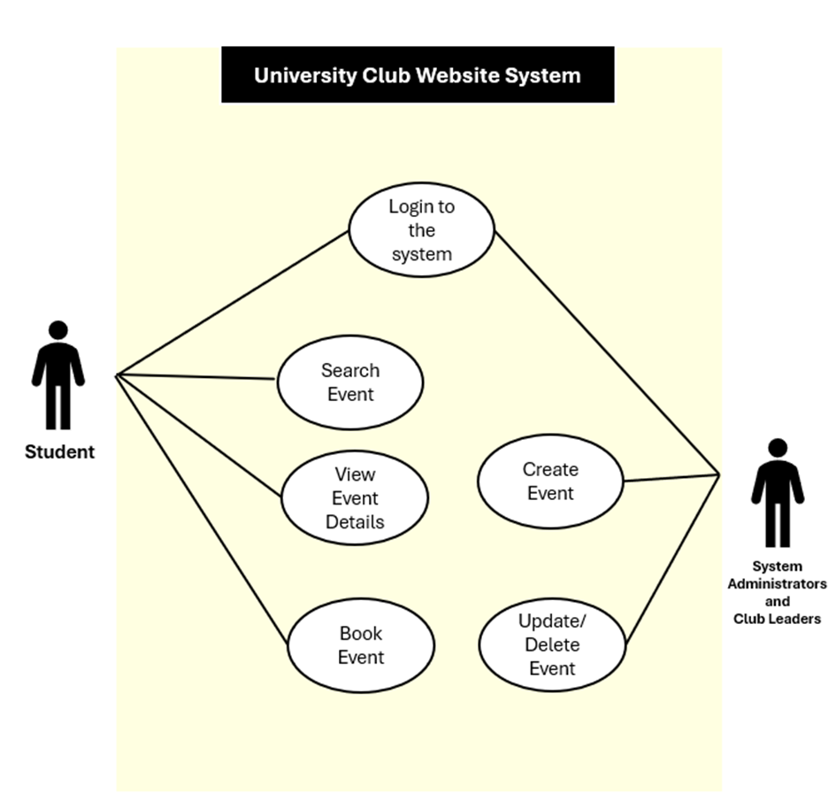

Figure 1: University Club Website Use Case Diagram.

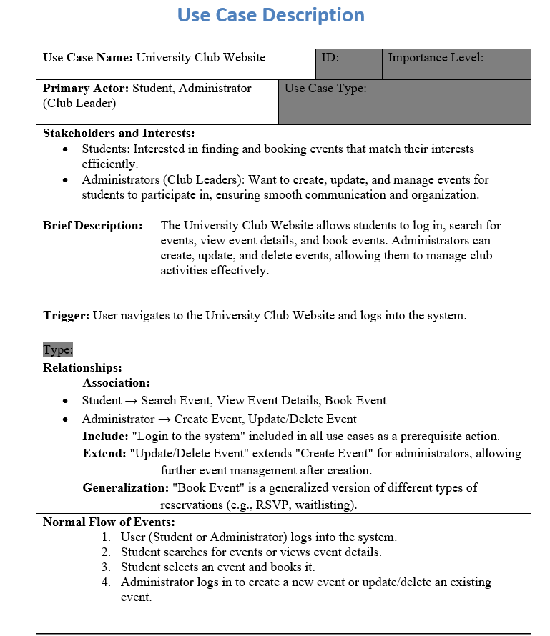

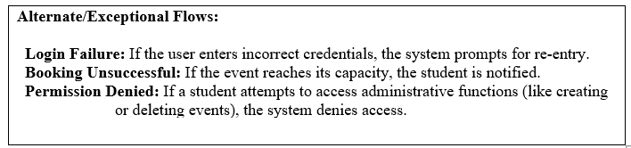

Other Nonfunctional Requirements

Performance Requirements
The system should meet the following performance benchmarks:

- Response Time: All pages should load within 2 seconds under normal operating conditions.
- Scalability: The system should support up to 1,000 concurrent users without performance degradation, accommodating peak times like the start of the semester or major event periods.
- Booking Processing: Booking requests should be processed within 1 second after submission to prevent double-booking issues.
- Database Query Speed: Database queries, particularly for event searching and filtering, should execute within 1 second under normal load.
- Uptime: The website should have an availability of 99.9% to ensure reliable access for users.

Safety Requirements
- Data Integrity: Measures should be in place to prevent loss or corruption of user data. Data backups should occur daily, and logs of all user interactions should be maintained for tracking.
- Event Overbooking Prevention: The system should ensure events do not exceed their maximum capacity to avoid issues related to overcrowding.
- Compliance with University Policies: The system must follow university policies regarding user data handling and content moderation for event listings.

Security Requirements
- User Authentication: All users must log in with a unique username and password to access event booking features. Two-factor authentication (2FA) should be implemented for administrators and club leaders.
- Data Encryption: Sensitive data, including personal information and user activity, must be encrypted both at rest and in transit using industry-standard protocols (e.g., SSL/TLS for data in transit).
- Access Control: User roles (student, club leader, administrator) should restrict access to specific features and data. Only authorized personnel (e.g., administrators) should access sensitive reports or make high-level changes.
- Compliance with Data Privacy Regulations: The system should comply with relevant data privacy laws, such as GDPR, to protect user privacy.

Software Quality Attributes
- Usability: The system should be intuitive and easy to navigate, allowing users to complete key tasks (e.g., event searching and booking) with minimal effort.
- Reliability: The system should consistently function as intended, with a low error rate.
- Maintainability: Code should be modular and documented, enabling easy updates and bug fixes.
- Scalability: The system should handle increases in user load without a decrease in performance, meeting the performance requirements set above.

Business Rules
- User Permissions:
  - Students: Can view events, book tickets.
  - Club Leaders: Can create and manage events, view event bookings, and interact with attendees.
  - Administrators: Can monitor all activities on the platform, approve events, and access user data for administrative purposes.
- Event Approval: Events created by club leaders must be reviewed and approved by administrators before being published on the platform. This ensures that events adhere to university policies, including content, date, time, and venue suitability. Until approval, events can be listed.
- Booking Limits: Each user can only book a single ticket per event by default, with the option for administrators to grant exceptions in certain cases.

Other Requirements
- Database Requirements: The system will use a MySQL database to store data on events, users, bookings, and club profiles, indexing will be done for data integrity and performance.
- Internationalization: It will be ready for multilingual support, the initial language is English, Turkish may be added in the future.
- Legal Requirements: Data privacy rules such as GDPR will be followed, users will have data access and deletion rights.
- Reuse Objectives: The code will be modular and documented, and will be developed in a way that it can be used in other projects.

Appendax A: Glossary
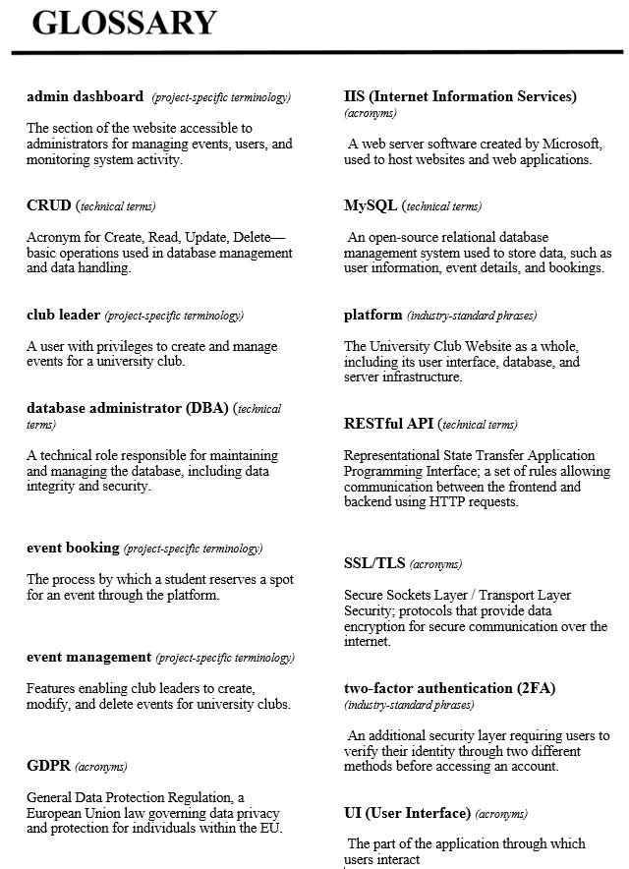

Appendax B: Analysis Models

Entity-Relationship Diagram (ERD)
Overview: This ERD outlines the key entities and relationships for the University Club Website, designed to manage student activities, club events, and reservation processes.

- Student - Reservation
Relationship: Makes
Description: A student can make multiple reservations for events.

- Event - Reservation
Relationship: Has Reservation
Description: An event can be reserved by multiple students.

- Club - Event
Relationship: Organizes
Description: A club can organize multiple events.

- Club Leader - Club
Relationship: Leads
Description: Each club has one leader responsible for it.

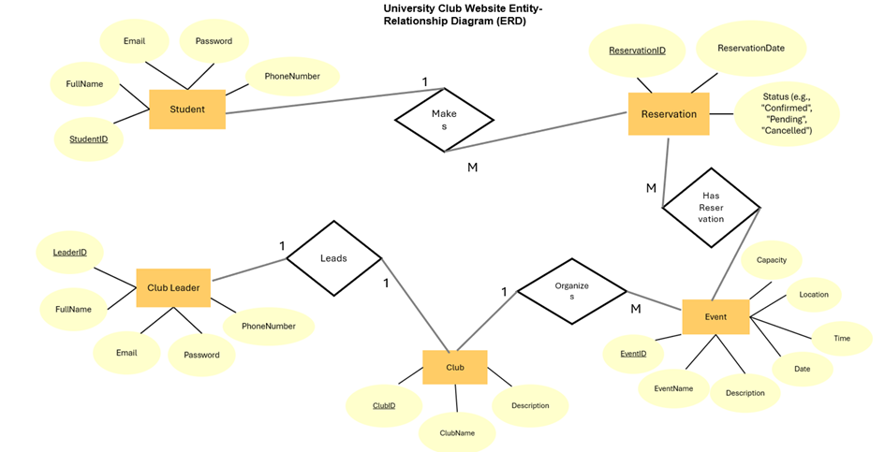

Figure 2: University Club Website ERD.

Relational Schema
The Relational Schema for the University Club Website defines how data is organized and related across the system. It includes five main tables: Student, Club Leader, Club, Event, and Reservation. Each table contains a set of attributes, with primary keys to uniquely identify records and foreign keys to establish relationships between tables.

The schema supports key functions of the website by allowing:

- Students to reserve multiple events,
- Clubs to organize various events,
- Club leaders to manage specific clubs.




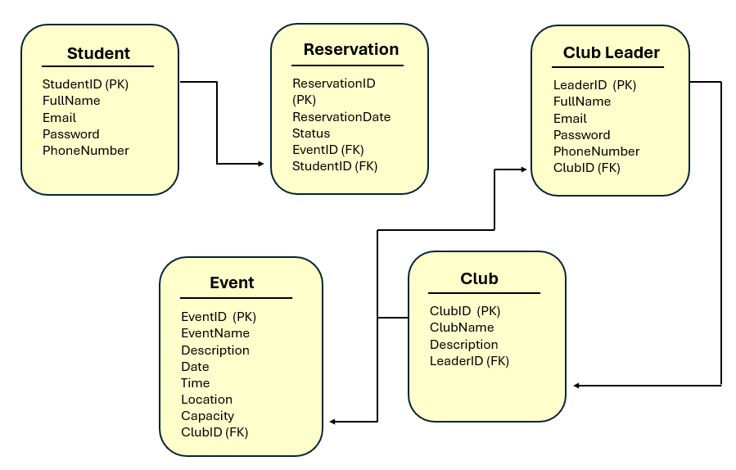

Figure 3: University Club Website Relational Schema.

Appendax C: To Be Determined List
The following items are marked as "To Be Determined" and require further clarification or decision-making before project completion:

- Security Enhancements: Decision on implementing additional security measures such as two-factor authentication (2FA) for club leaders and administrators.
- Email Notification System: Confirmation on whether to implement email notifications for booking confirmations and reminders. This decision will determine if users receive email updates for their bookings and scheduled events.

